Children Helping Elephants
Asks Seattle Leaders
To Send Chai and Bamboo to a Sanctuary
April 6, 2015

Children Helping Elephants is a child-generated movement working to send Seattle’s elephants, Chai and Bamboo, to a sanctuary.

The families of Seattle need the help of Seattle’s leaders to prevent a big mistake.
In this packet you will find samples of our words and our art advocating for sanctuary.
Please stop the Zoo from going forward with this unethical act.
The people of Seattle do not agree with this decision.
We must be on the right side of history.

.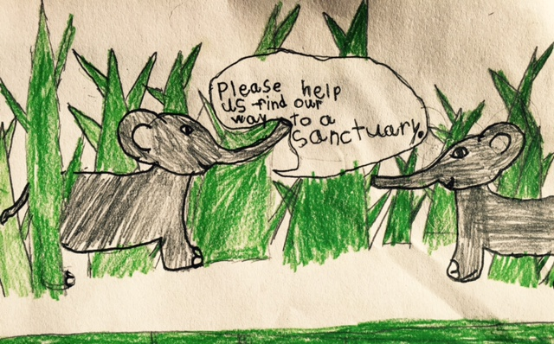
Stella, Age 7

Children Helping Elephants
www.ChildrenHelpingElephants.org
children4elephants@icloud.com
206-371-7542
@kids4elephants
April 5, 2015

To The Executive Leadership Team of Woodland Park Zoo, Seattle Mayor Ed Murray, the Members of the Seattle City Council, and all others charged with ensuring the well being of Seattle’s elephants, Chai and Bamboo:

We ask that you send Chai and Bamboo to a sanctuary, not to Oklahoma City Zoo.
The following petition statement is a compilation of children’s quotes collected by Children Helping Elephants. Contributors range in age from 4-16 and come from all across the Seattle region. Here is what the kids say:
“What happens to elephants matters to us. Elephants are living creatures with minds of their own. They have feelings, just like you and me. They need a lot of space to move their bodies and be healthy. When they never get to explore or see new things, they get bored. Sometimes they get mad. Wouldn’t you be mad if you weren’t allowed to decide what to do with your own body? How would you feel if you were behind a fence with nothing to do and lots of strangers stared at you every day for your entire life?

When we watch elephants in zoos, we aren’t watching them be elephants. We are watching them be sad. We don’t need elephants in zoos so that we can learn about them. There are so many other ways to learn about elephants that are more interesting and that don’t make elephants sad and unhealthy. Watching the elephants on sanctuary cameras, we can see them being their elephant selves. We see them feeling relaxed, being friends, playing. It’s not the same as watching what they do in the wild, but they are so much happier than zoo elephants. The only thing we learn about elephants from zoos is that zoos aren’t right for elephants.

What the zoo is doing to Chai and Bamboo is wrong. It makes us worry that they are doing wrong things for other animals too and that makes us not want to go to the zoo anymore.

We ask all the adults who agree with us to sign this petition. It will also help if you write a letter to the zoo so they will know that we all care about Chai and Bamboo. We ask kids who care to make art for the elephants and share it with us so we can see other kids’ ideas.
Please help us save the elephants.”

The Kids of the Children Helping Elephants movement, Seattle, WA
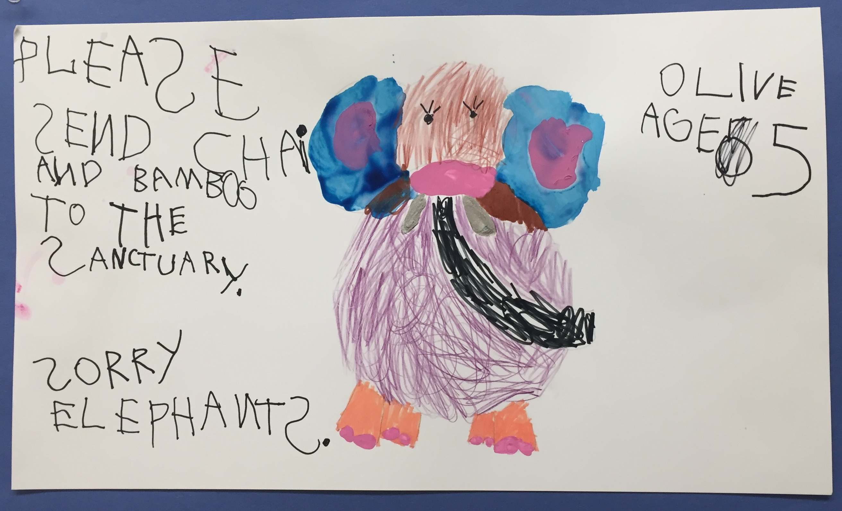
Olive, Age 5
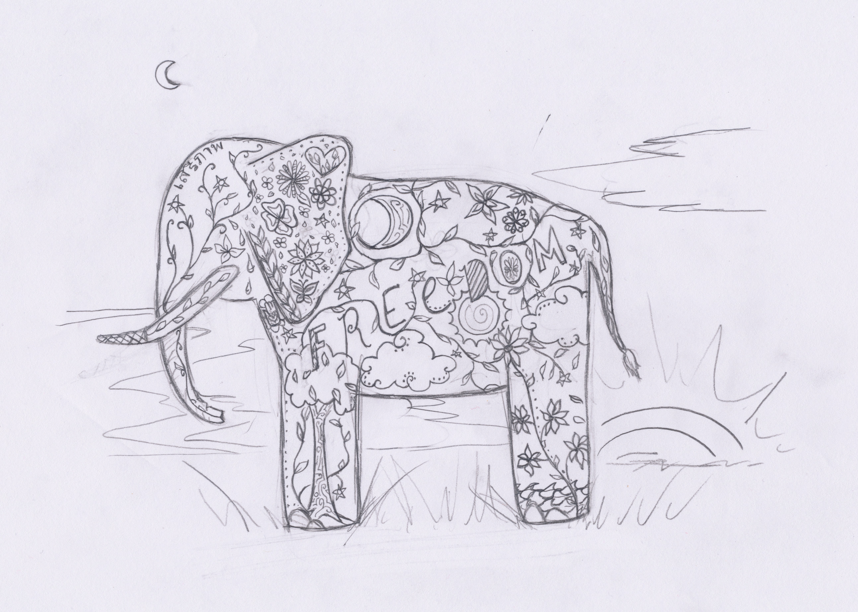
Samantha, Age 15
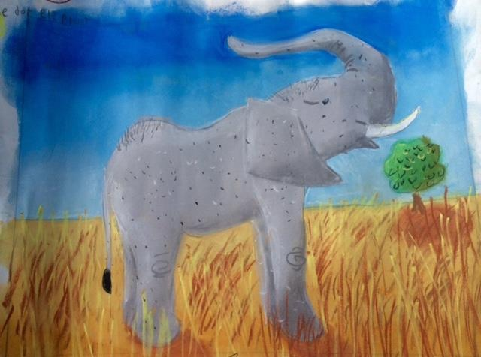
Sophie, Age 10
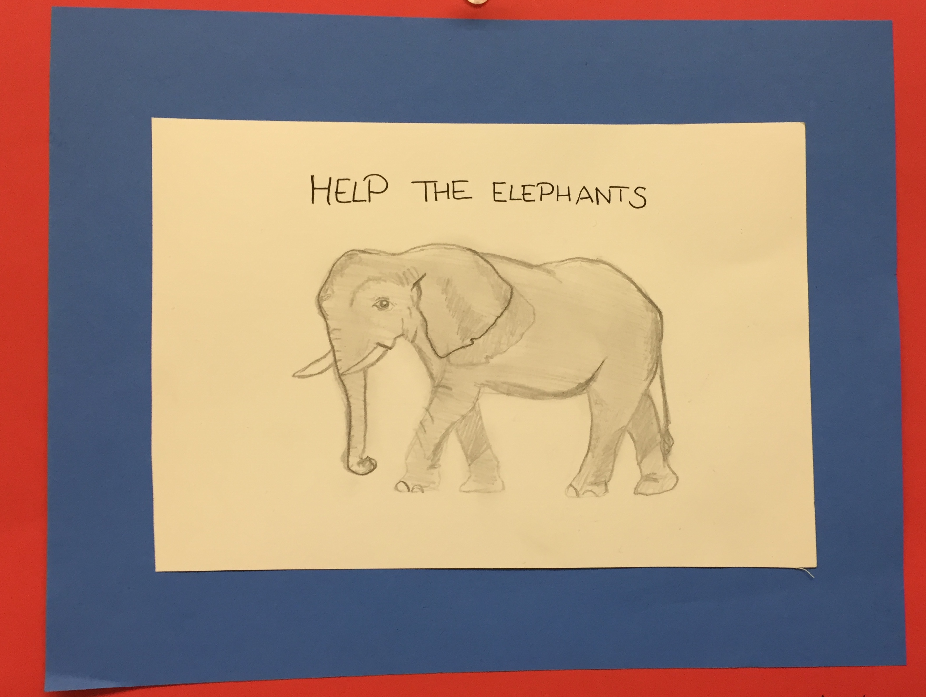
Emily, Age 16
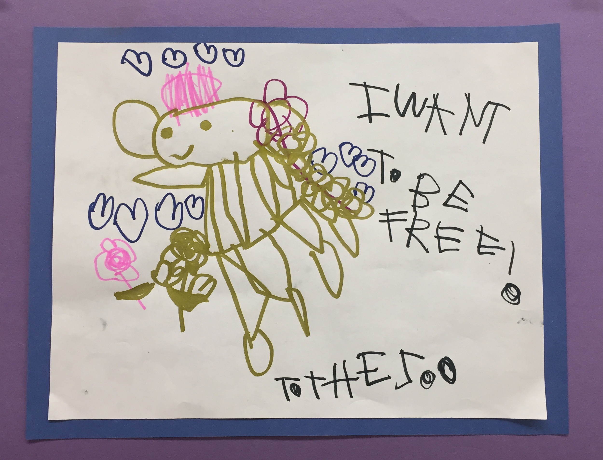
Doria, Age 4
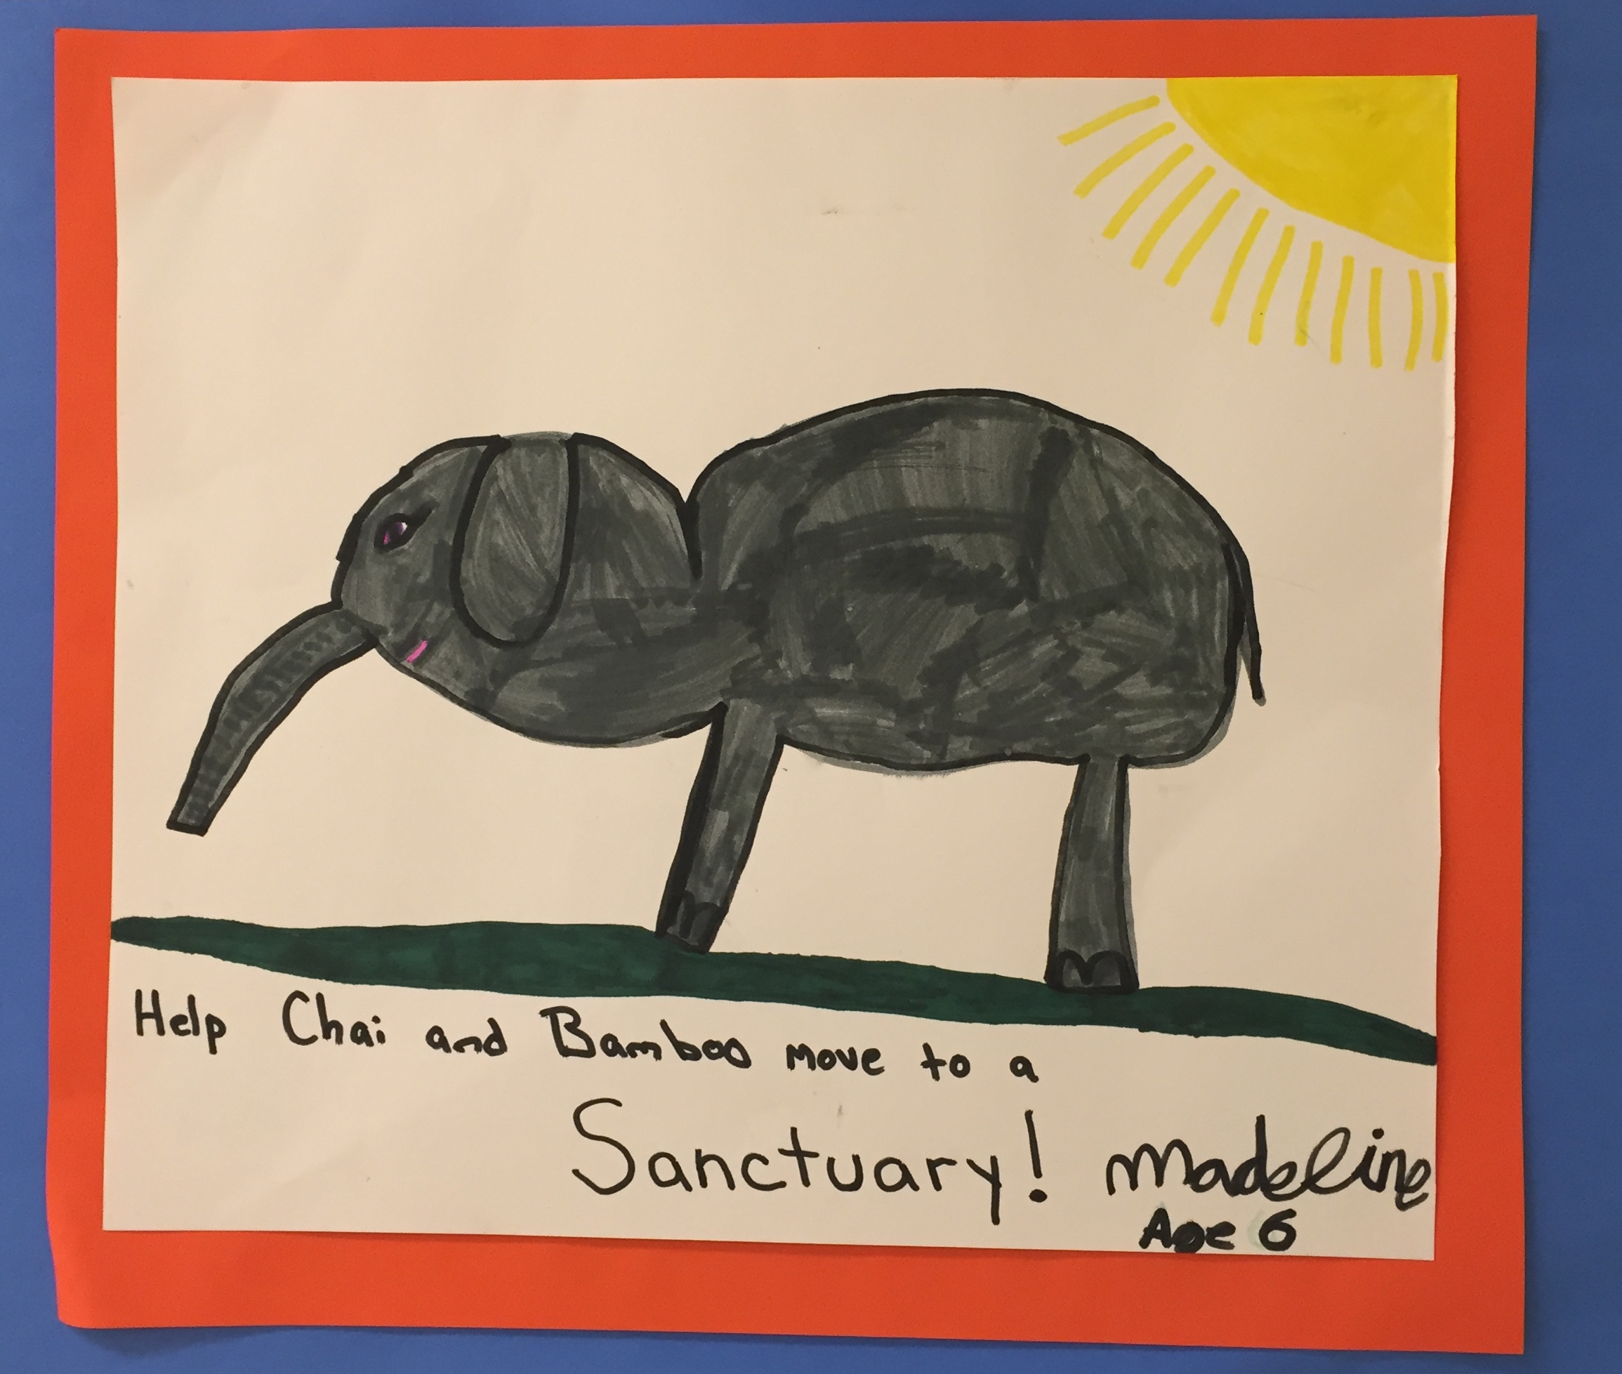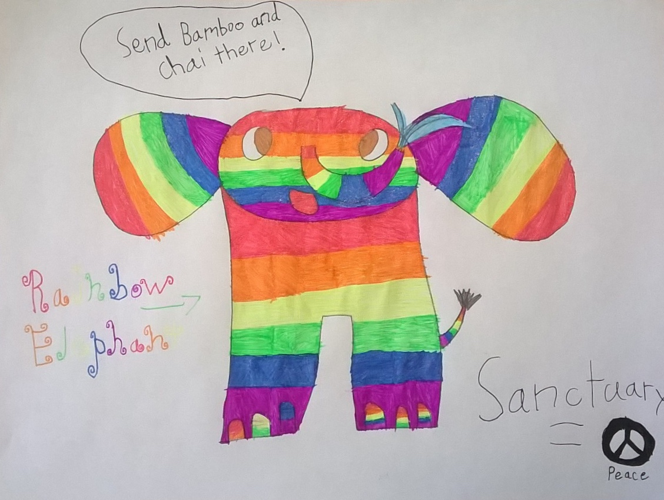
Madeline, Age 6
Ruby, Age 8
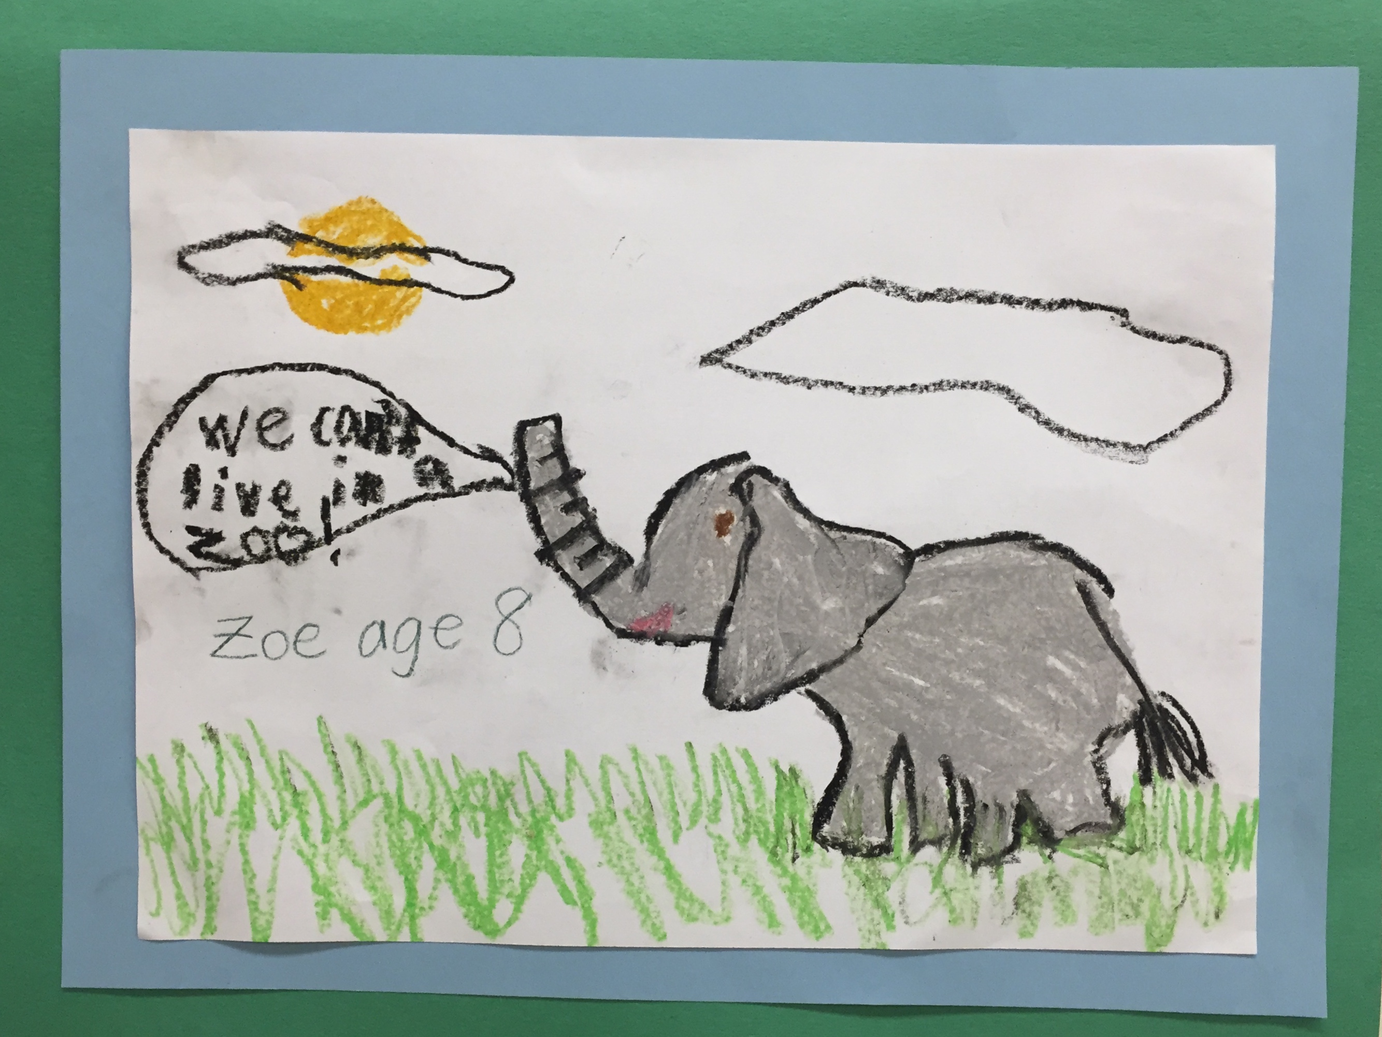
Zoe W., Age 8
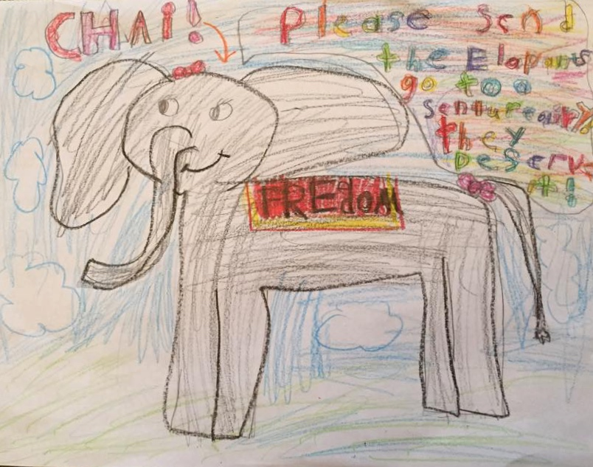
Zoe G.B., Age 8
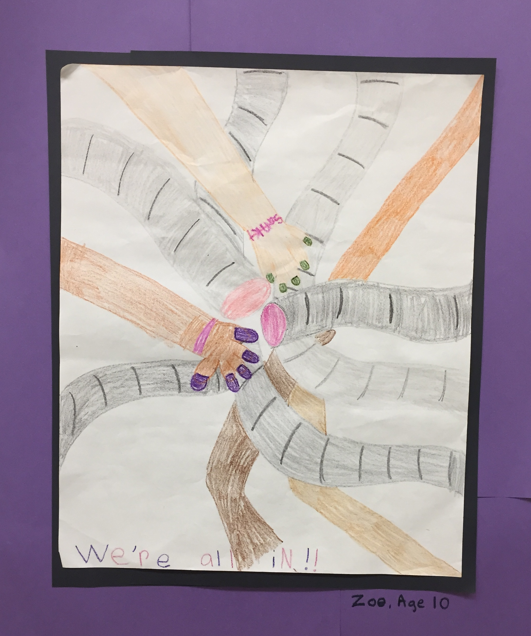
“We’re All In”
Zoe C., Age 10
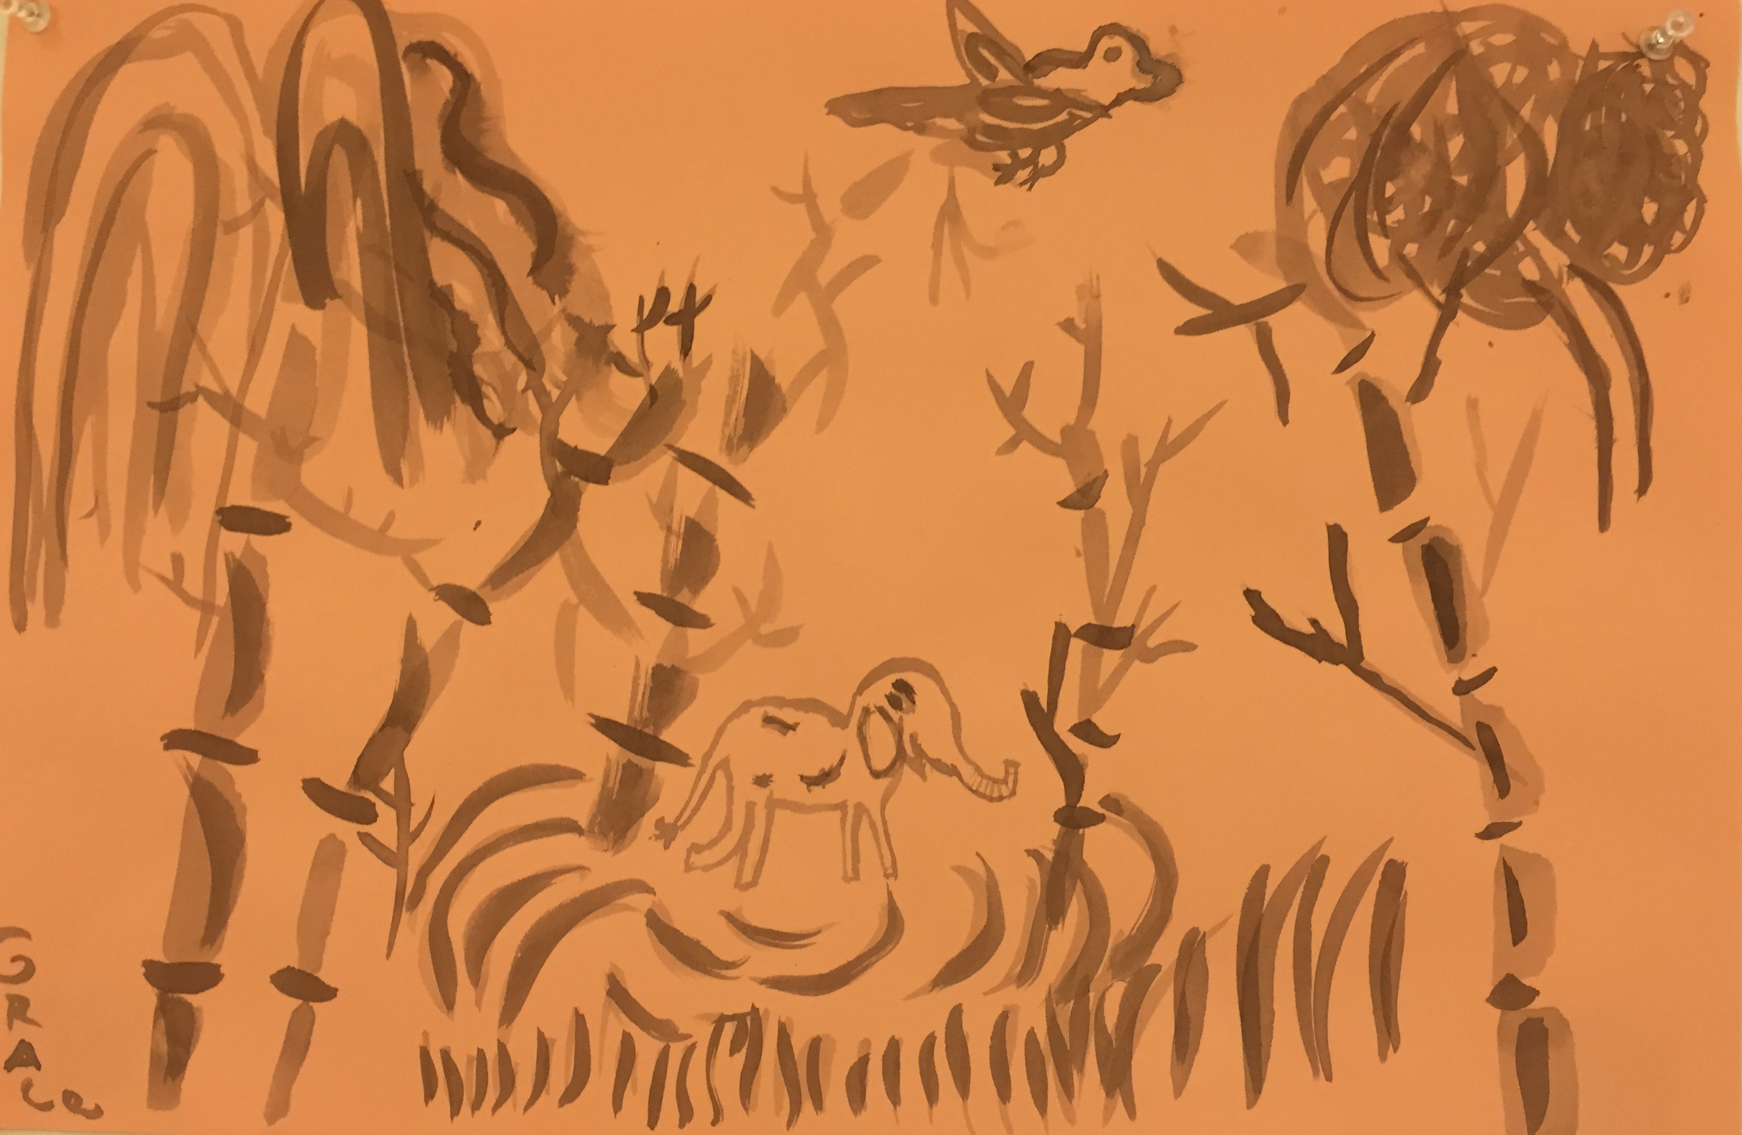
Grace, Age 9
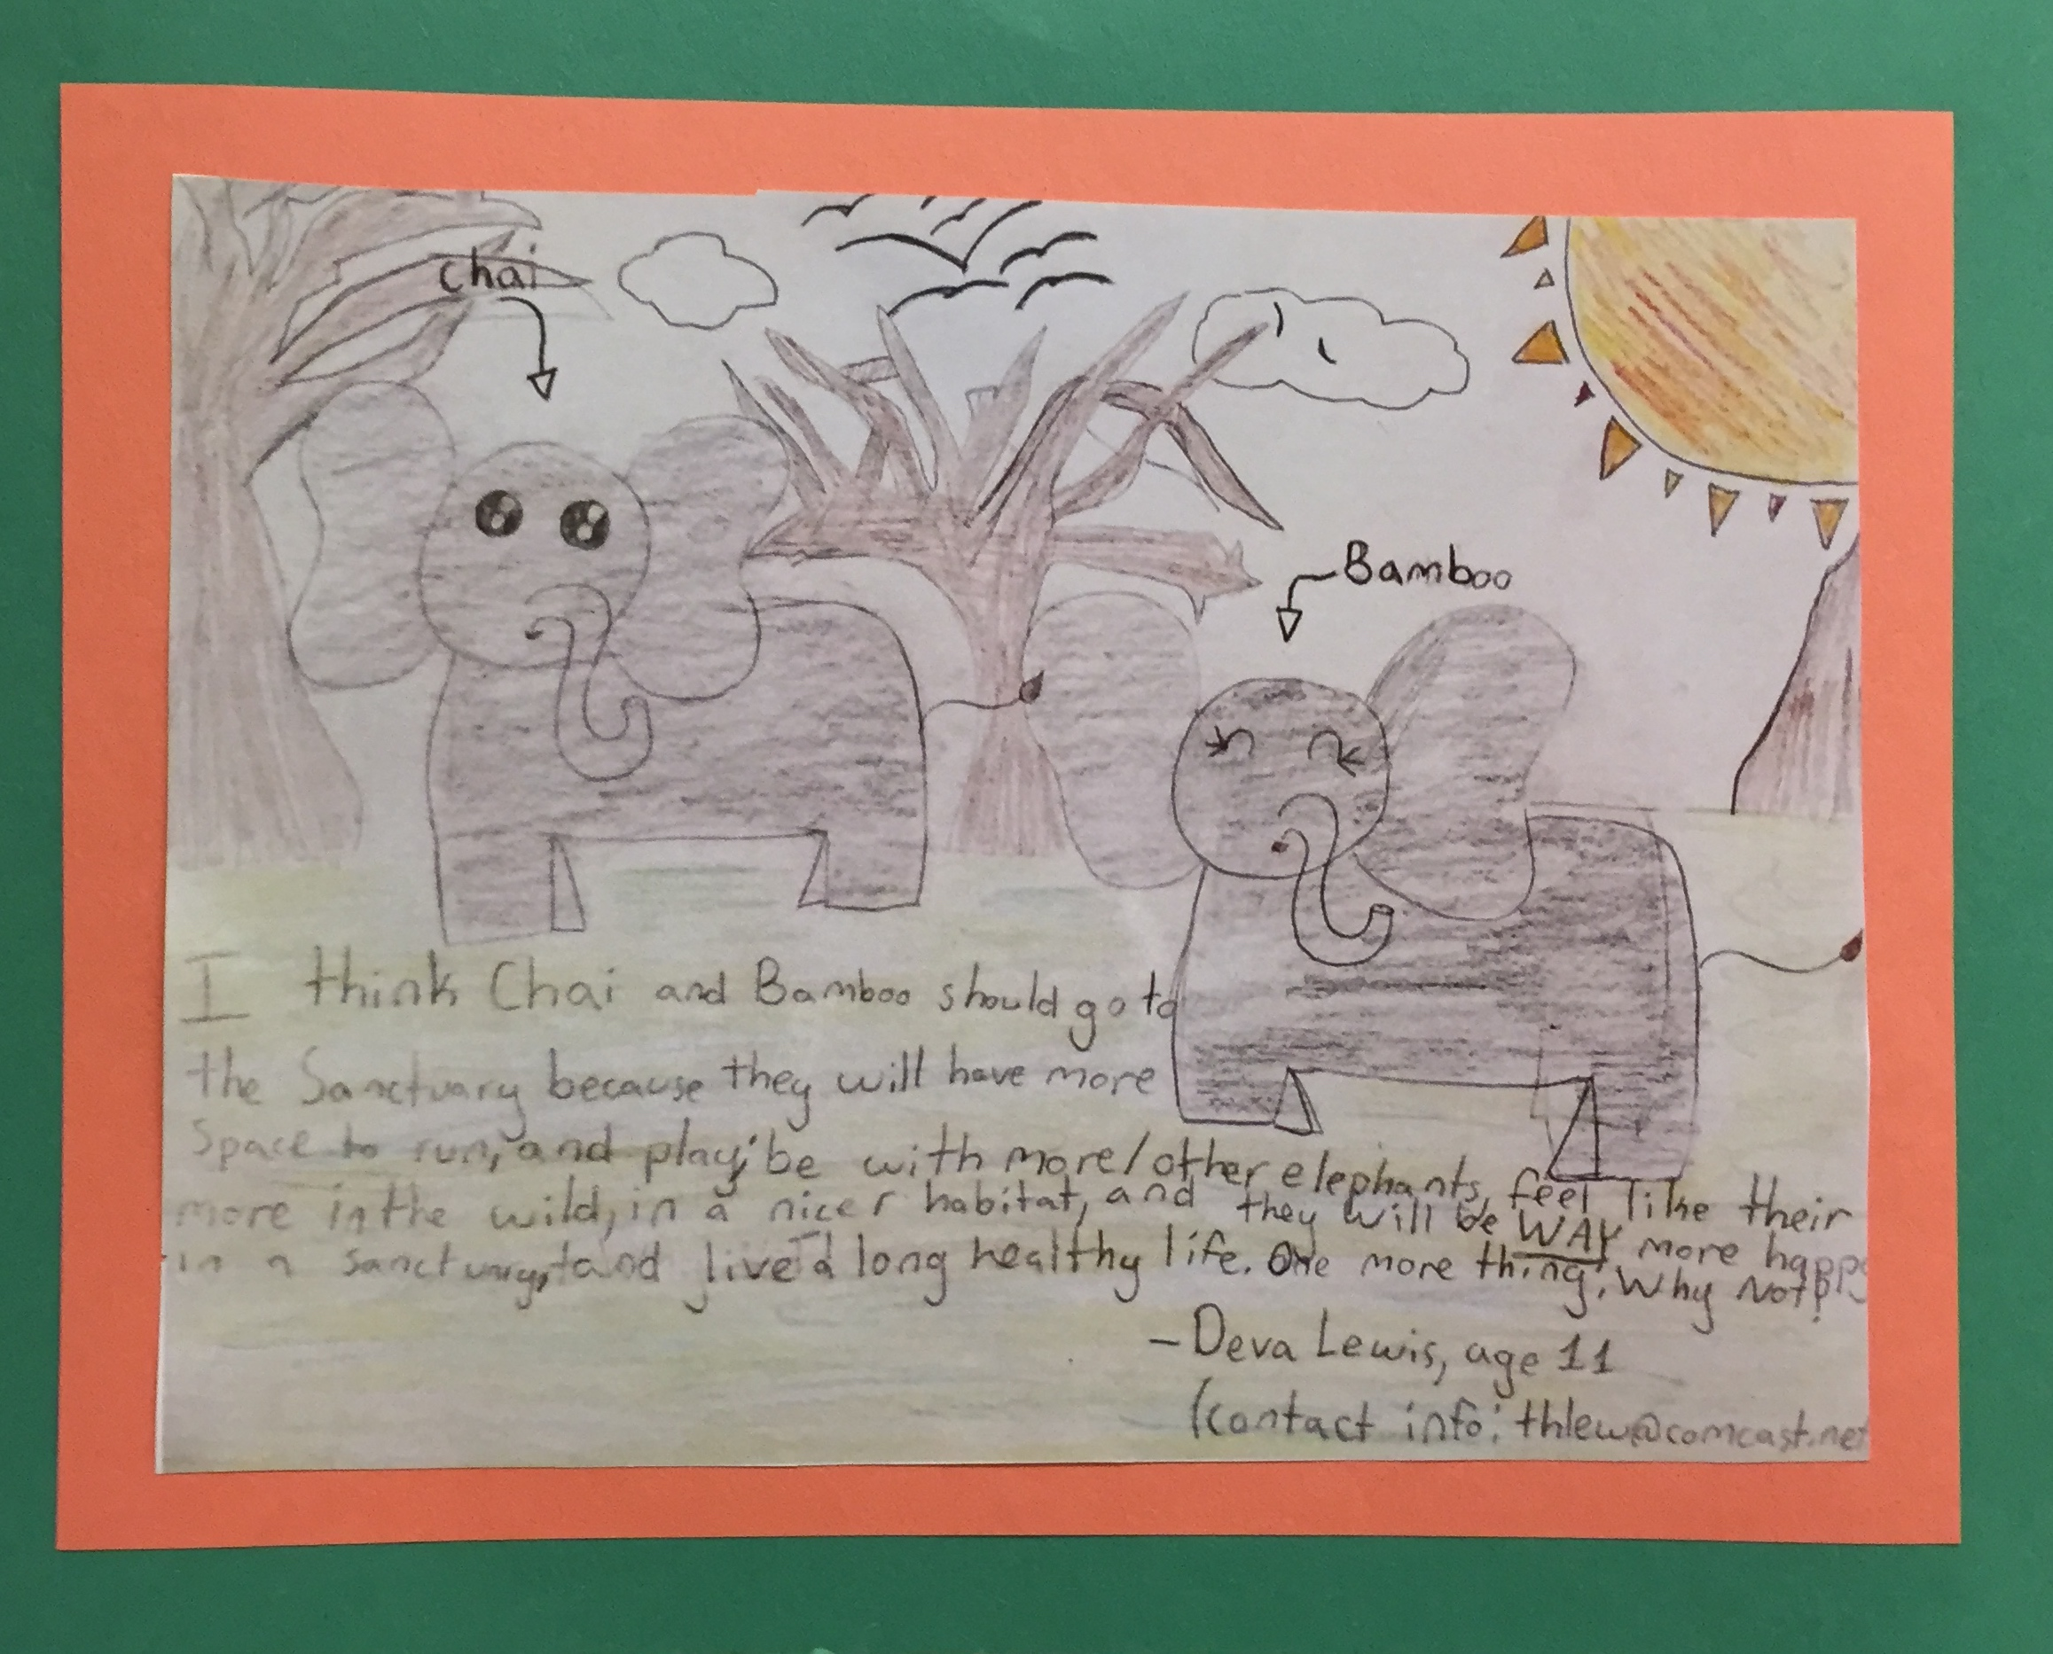
Deva, Age 11
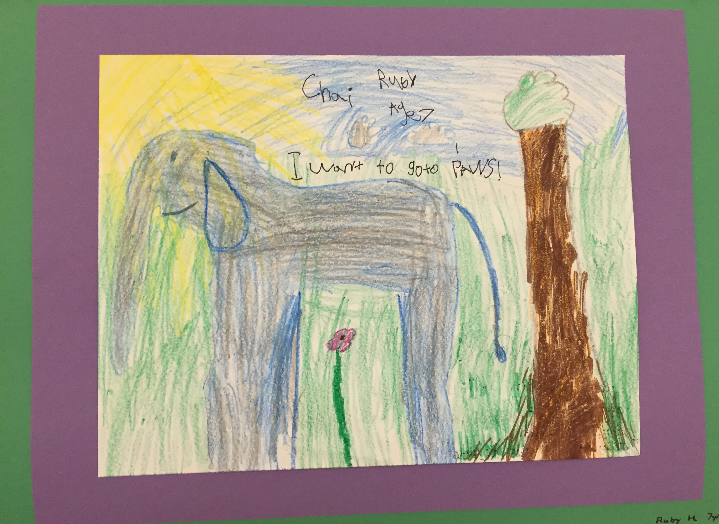
Ruby, Age 7
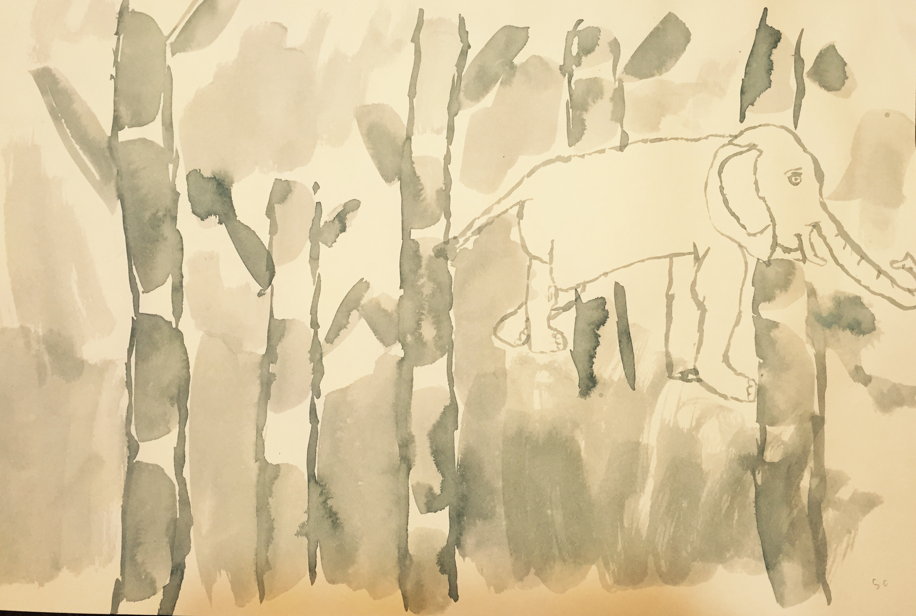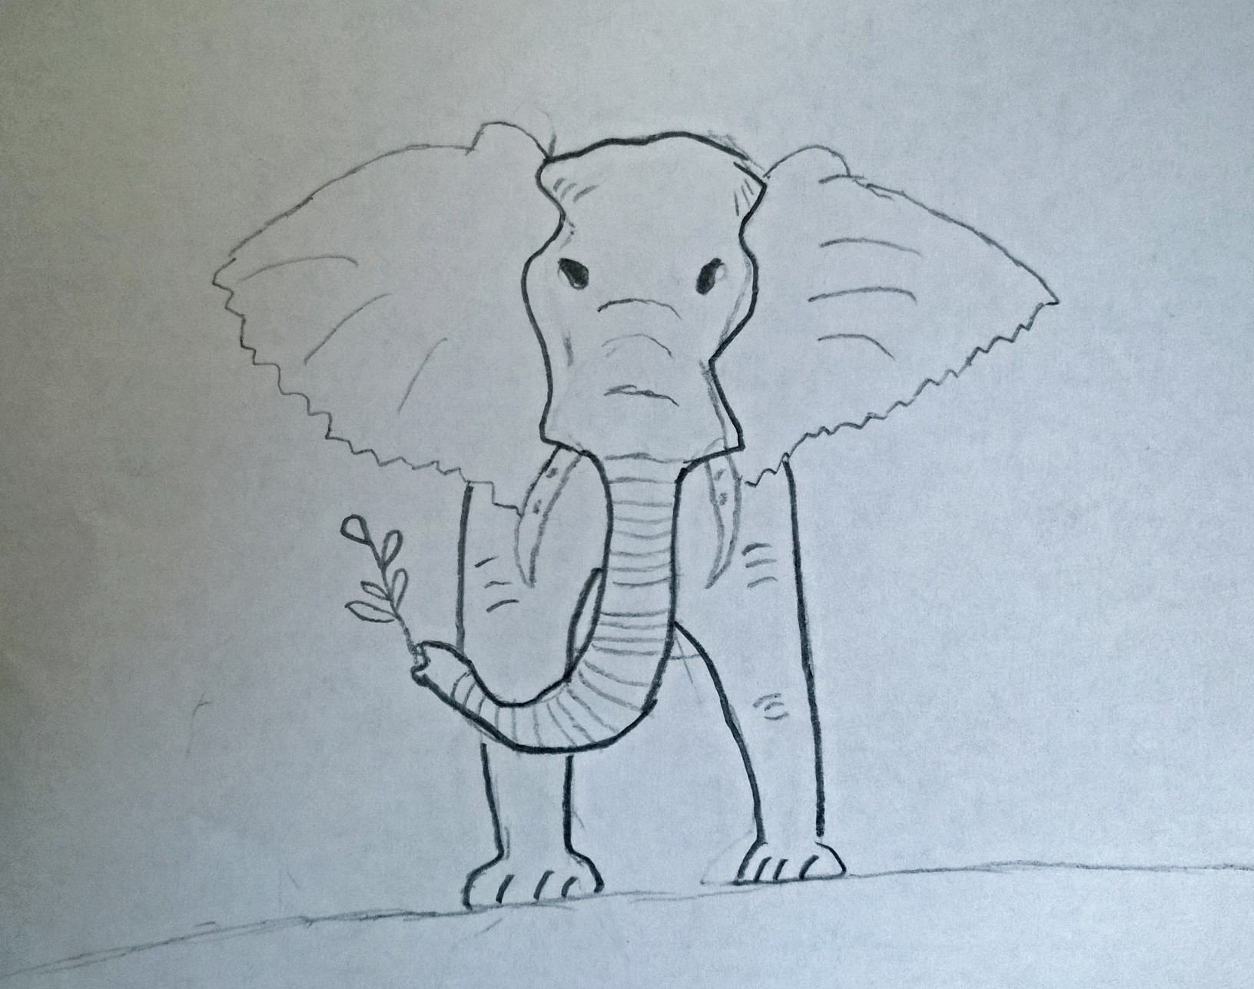
Stella, Age 8
Charlie, Age 12
Statement by Autumn Miller, Age 8

The elephants are very important to all of us.

We want Chai and Bamboo to go to a sanctuary.

We do not like how they are being treated.

We do not understand why the adults are having such a hard time making the right choice.

We do not need a single elephant in the zoo to learn about them because there are other ways to learn about them like books and documentaries, that don’t make them hurt inside.

What the zoo is doing to the elephants is wrong.
It makes us wonder if they are doing wrong things for all the other animals too – and that makes us not want to go to the zoo anymore.

Please help Chai and Bamboo.

Thank you very much.

Statement by Lisa Decker, co-founder of Children Helping Elephants:

We need our leaders to hear clearly that the families of our region want Chai and Bamboo to go to a sanctuary. We are zoo members or former zoo members who can no longer support the zoo in good conscience. I entered this effort as an objective parent with an inclination to view the Zoo in a positive light, but it has become obvious to me that this decision is guided neither by science nor morality, but by an entrenched, outdated ideology that is out of step with our current knowledge and the moral values of our community. It is wrong. This matters. It is not a fringe issue. It speaks to the core of who we are just like equal marriage rights, the minimum wage or affordable housing. We are a community of forward thinking citizens. We are leaders on ethical issues. Most of the time, we are on the right side of history. We are about to make a huge mistake here, and we need your leadership to stop it.

Many defenders of the decision are looking at what we are doing and saying, “Oh, so now kids are the experts?” We would do well to spend far more time listening to children. They are not looking through lenses fogged by political pressure, financial implications and institutional histories. They have an intuitive understanding of sadness and injustice. And they are absolutely experts about how they learn.
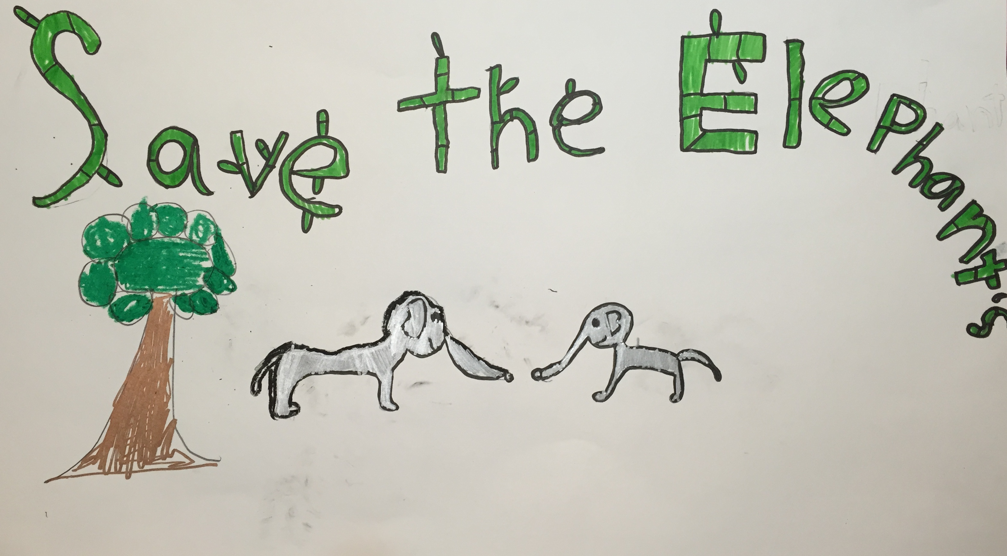
Terra, Age 8

